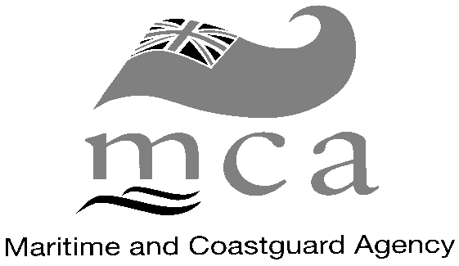

An executive agency of the Department for Transport

Bay 2/21, Spring Place, 105 Commercial Road, SOUTHAMPTON, SO15 1EG
Tel: +44 (0)23 80329182 Fax: +44 (0)23 80329204
e-mail: dangerous_goods@mcga.gov.uk

REQUEST FORM (Hot Air Balloon Cylinders)

Please complete the following questions and sign the declaration after having carefully read the enclosed note. Return the form, signed to this office.
Name :

Address :

Postcode :

Your Ref : Telephone: Fax:

Balloon Registration :

Proper Shipping Name: PROPANE

UN Number: 1978

Recognised Chemical Name: 100% Propane (compressed)

Class: 2.1

Description of how the cylinders are stowed:

mca REQUEST FORM CONTINUED.
TRADING LIMITS (see Note A):

Note A: 1 = local, domestic inter-island services
2 = short international voyages (e.g. cross-channel or Irish sea crossing)
3 = World wide.

Please read the statements below carefully before signing.

DECLARATION:

I hereby declare that;

1. These goods have been correctly identified and classified in accordance with the current edition of the IMDG Code.

2. The flight cylinders are listed in the Aircraft Logbook and have been annually inspected by a BBAC appointed Inspector.

3. The aircraft has a current IR4, which is in the Aircraft Logbook.

4. I hold a current hot air balloon/airship licence.

Signed.........................................................

Name...........................................................

Status of Signatory........................................

Date.........................................................…

